OATA Diversity and Inclusion Committee
Fast Facts – February
Black History Month
- Skin Conditions present differently on different colors of skin. Here are some common skin conditions and how they could present on various skin colors:
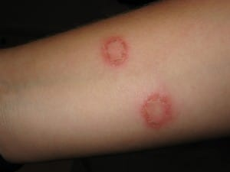
  - Ringworm
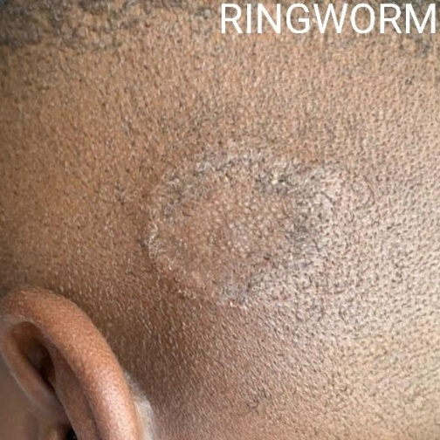
  - Impetigo
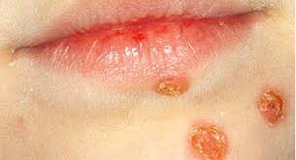


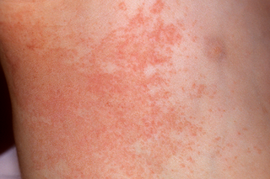
  - Heat Rash
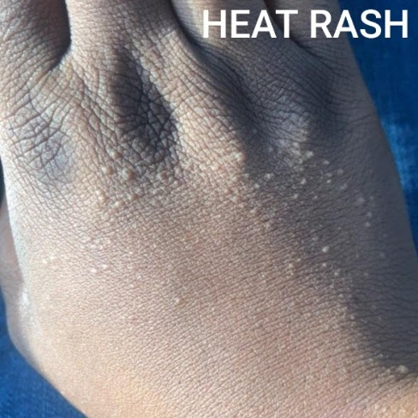

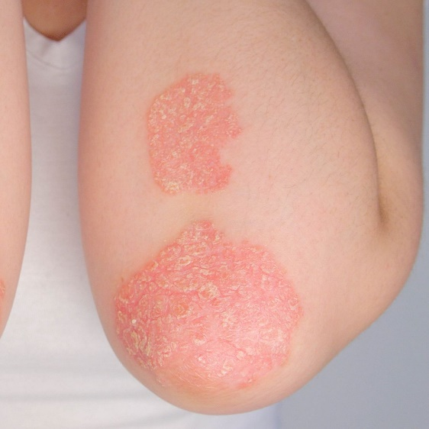
  - Eczema
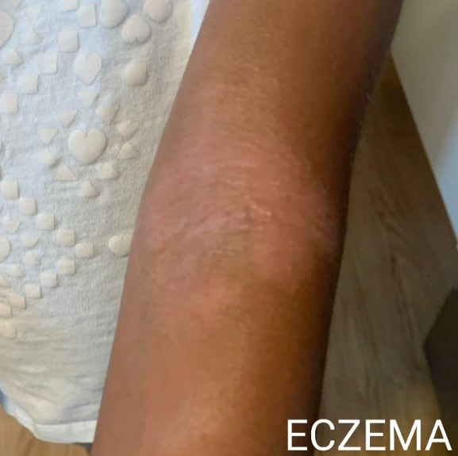

  - Skin Conditions on Non-White Skin, BrownSkinMatters website. Brownskinmatters.com Accessed February 1, 2022.
- The importance of black athletes using sunscreen.
  - It is a myth that African American Athletes don’t need sunscreen like white and lighter skinned athletes. Because of these myths, many African Americans received late prognoses for many forms of skin cancers. In fact, black people are four times more likely to be diagnosed with advanced stage melanoma and tend to succumb at a rate of 1.5 times more than white people with a similar diagnosis.
  - Mahendraraj, Krishnaraj MD; Sidhu, Komal MD; Lau, Christine S.M. MD; McRoy, Georgia J. MD; Chamberlain, Ronald S. MD, MPA, FACS; Smith, Franz O. MD, FACS Malignant Melanoma in African–Americans, Medicine: April 2017 - Volume 96 - Issue 15 - p e6258 doi: 10.1097/MD.0000000000006258
- Diversity statistics in the athletic training profession:
  - Less than 6% of ATCs are ethnically diverse. Around 60% of collegiate athletes are. There is an imbalance between the ATC and Athletes.
  - In January of 2022, the NATA recorded over 38,000 members with only 18.83% of them being ethnically diverse. Of that 18.83%, only 3.79% (1220 members) of members identify as Non-Hispanic African American.
  - Of the 1220 members who identify as African American, 25.16% work in the collegiate setting, 21.8% work in the secondary school setting, and 26.6% are students in a CAATE accredited program.
  - William M. Adams, Aaron B. Terranova, Luke N. Belval; Addressing Diversity, Equity, and Inclusion in Athletic Training: Shifting the Focus to Athletic Training Education. J Athl Train 1 February 2021; 56 (2): 129–133. doi: https://doi.org/10.4085/1062-6050-0558-20
  - NATA membership statistics. National Athletic Trainers' Association Web site. https://members.nata.org/members1/documents/membstats/index.cfm. Accessed Feburary 1, 2022.

